SOP (Standard Operational Procedure)
Recycle Hub Imaji Lingkungan Jatisari

The SOP (Standard Operating Procedures) aims to provide clear direction and guidance to the operators and workers of Recycle Hub to undertake waste recycling and management activities, from the collection to the management. The SOP also regulates the sequence and work mechanism to be implemented at Imaji Lingkungan Recycle Hub.

Most of source of the Recycle Hub’s raw materials includes:
1. From the communities' trash bins.
2. From industrial waste bins.
3. From the trash of the organization/institution

The materials will be collected by the Waste Bank and Collection Point, then to be transferred to the Recycle Hub. Waste Bank, Collection Point and Recycle Hub’s staff should receive training in plastic waste collection and segregation techniques to ensure the quality of raw materials for the Recycle Hub.

Service
Person in Charge: Procurement Operator

Pick-up trucks operate daily in Jember area to collect materials from the Waste Bank and Collection Points within 15 km. Recycle Hub provides various services to the suppliers and partners with the following details:
- Purchase
Recycle Hub procure the raw materials in accordance with its needs and type of materials. The Waste Bank and Collection Point may make purchase transactions at the Recycle Hub. There are several purchase methods, including:
- Clean Materials Ready for Recycled (SG)
Suppliers can sell clean materials that have been segregated and sorted according to the type of material needed by the Recycle Hub.
- Recycling Service (Shredding and Press)
The Recycle Hub also offers recycling service for partners who wish to shred and baled press the raw materials owned by the partners.
- Mixed Selling
This type of sale will be carried out at TPST Harapan Baru Dukuh Dempok for sorting and segregation before it is ready to be recycled.

- Weighing
Weighing will be done twice; first at the supplier's location whereas the type and weight of raw materials are recorded following the applicable price on that day and issuance of Delivery Order from the supplier. Secondly upon arrival at the Recycle Hub to match the type, weight, and price of the materials. Receipt will then be issued by the Recycle Hub officer, with example as following:
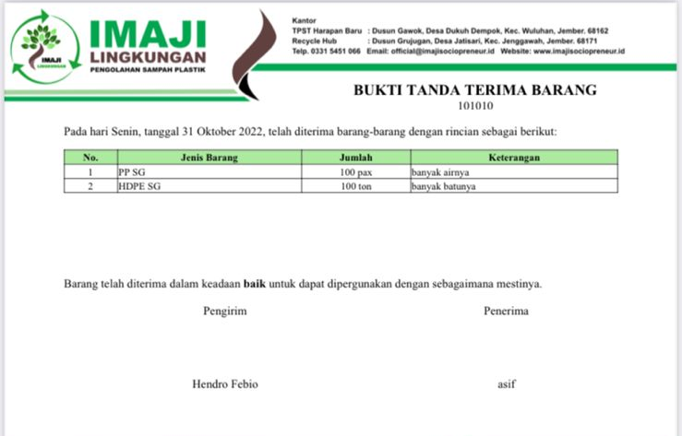
Figure 1. Receipt of Raw Materials

- Transportation
Transportation costs for both delivery and pick-up will be determined by the supplier and Recycle Hub based on the mutually agreed terms and agreements.

- Payment
Payment will be made in 2 (two) terms; first payment is 30% when the materials are delivered/picked up and the remaining 70% will be paid after the materials are cross-checked at the Recycle Hub, including the type, weight and price of the materials are verified by the officer. If there is any mismatch of raw materials, the volume will be automatically deducted, and the mismatched materials should be returned to the supplier in the next pick-up schedule or destroyed. Suppliers are strictly prohibited for deliberately putting hazardous and toxic materials into the raw materials. In case such incident is found, we will impose a sanction of cancelling the transaction or terminating the agreement.

Sorting
Person in Charge: Production Operator

The sorting and production officers consist of 3 (three) people with the following responsibilities: 1 (one) person is responsible for sorting and preparing materials ready for recycling. The sorting process is adjusted to the applicable and order of the recycling process (shredding or pressed). One (1) person oversees operating the shredding and pressing machine including putting plastic waste into the machine, 1 (one) other person oversees filtering and putting the shredded materials into the sacks, binding the bale-pressed materials to be stacked and grouped by type and the quality of the shredded and bale-pressed results.
Table 1. Processing category of plastic waste
Type Raw Materials | Collection | Bale Press | Shredding
PET bottle | ✅ | ✅ | ❌
HDPE receptacle/ bottle | ✅ | ❌ | ✅
pp containers/ cups | ✅ | ❌ | ✅
Plastic Soft | ✅ | ✅ | ❌

In general, recyclable plastic waste should be divided into several categories and groups as follows:
  - Disposable Single-Use Hard Plastic, consists of PET and HDPE & PP.
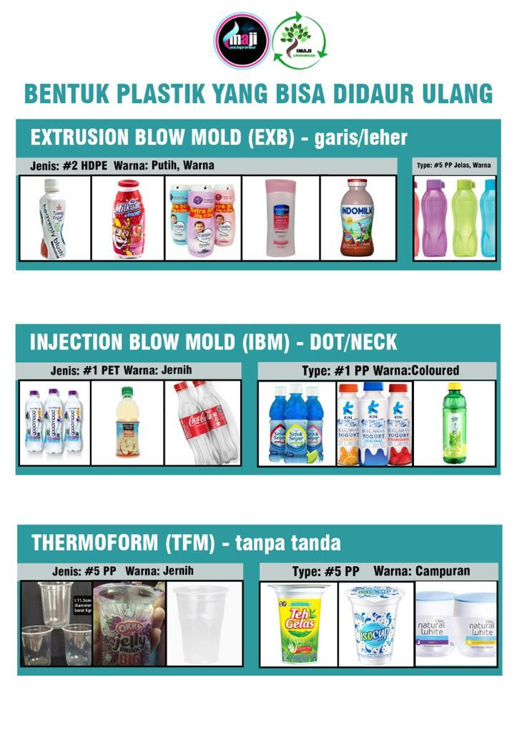
  - Disposable Single-Use Soft Plastic, consists of clear plastic packaging or plastic bag, made from single layer of Polyethylene (PE).

Figure 2. Recyclable Plastic Waste at Recycle Hub

The sorting process consists of some sub-processes as follow:
- Segregation
Soft plastics should be separated from other plastics, as the recycling process will depend on the type of plastic.
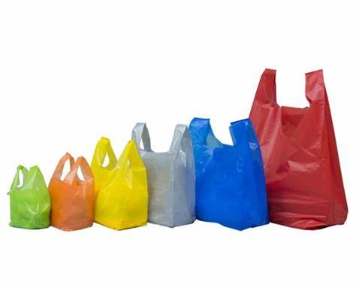
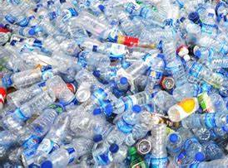

Figure 3. Sample of Soft Plastic
Figure 4. Sample of Plastic Bottle

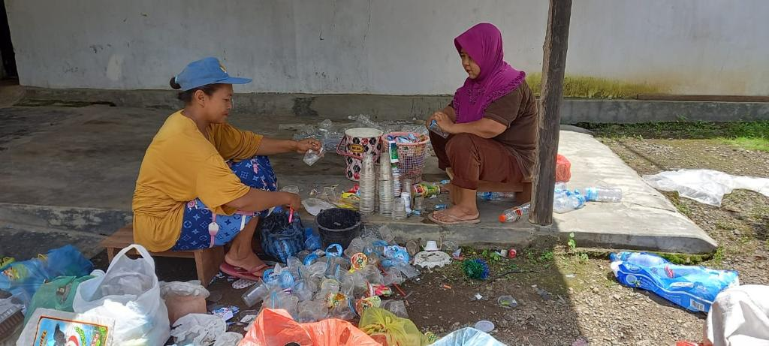
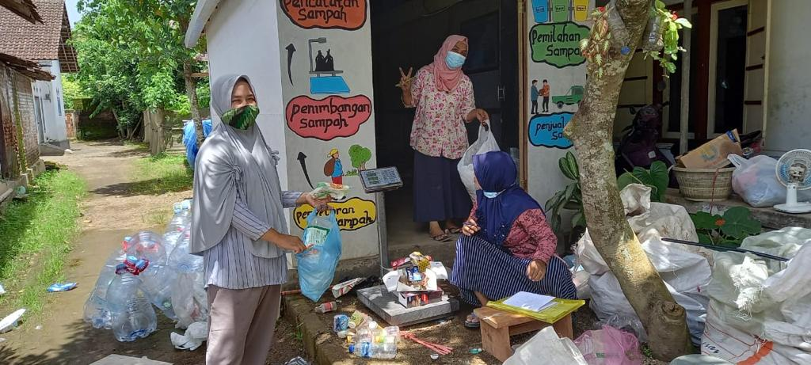
- Cleaning
During this process, any containers or wrappers containing food or drink residue must be separated and cleaned first. No other material such as iron, wood, cement, mud shall be included into the shredding machine.

Figure 5. Sorting Activity Figure 6. Cleaning Activity

- Sorting based on Type and Category
Sort each category of raw material into the following type using the RIC (Recycling Identification Code) plastic ID below:
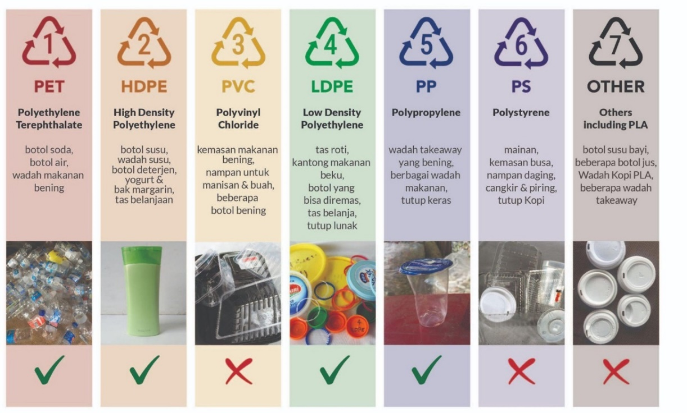

Figure 7. Classification of Plastic Waste
The Recycle Hub only accepts three types of single-use plastic and the raw materials shall be sorted based on each type as follow:
- 1 PET IBM (PET-injected printed blow, example: water bottle)
- 2 HDPE EBM (HDPE Extrusions Blow Mold, example: milk bottles, yogurt, shampoo, cosmetic containers)
- 3 PP THF (PP thermoform, example: tray, cup or lid, tea & water cup)

- Preparing for Recycling Based on Sorted Type
Raw materials are collected according to the processing flow. The bale-press include PET and soft plastics depending on the needs of the buyer, while the shredding process is for HDPE, PP and LDPE that have been segregated before.

- Quality Inspection
Raw materials ready for recycling should be re-examined and divided into several quality grades:
- Grade A1: Very clean, no contamination (less from 5%)
- Grade A2: Clean, minimum contamination (less from 10%)
- Grade B: Dirty, medium contamination (up to 20%)
- Grade C1: Very dirty, high contamination (up to 40%)
- Grade C2: Mixed plastics
- Non-Recyclable/Hazardous Materials

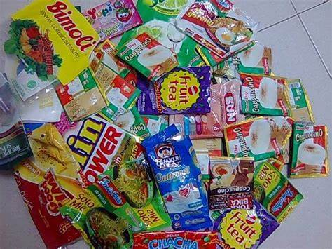
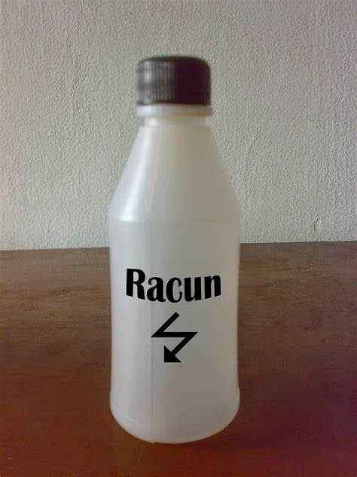
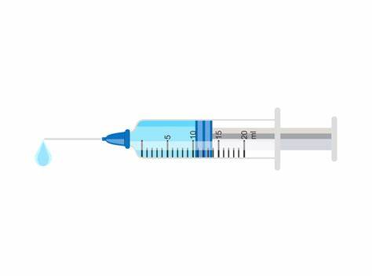

Bottles of poison/pesticide
Used syringe
Multilayer packaging
Figure 8. Sample of non-recyclable and hazardous materials
The grade of ready-for-recycled materials can be checked whether there is contamination of other material in each sack. For instance, when the operator undertakes grading process to the clear PP materials, then he/she must ensure there is no other materials included in the sack, such as color PP or paper packaging glued to the materials. If any contamination is found, then the materials shall be re-grade based on the current classification.

- Remove label, cap, ring
If raw material is still found to be contaminated after grading, the production operator should clean the raw materials. Bottles with caps and rings should be separated, due to the different type of materials. For example, PET bottles have HDPE or PP lids, while HDPE milk bottles generally have LDPE lids. All bottle caps are stored in a container according to each type and color.
Labels that are not glued on PET bottles can be easily removed, as they are usually LDPE (soft plastic), whereas labels on HDPE bottles are glued on and more difficult to be removed. Fill in the bottle with hot water or heat the bottle in the sun to remove the label easily. PP containers usually have a spray on label made of PP, which cannot be removed, but can be included for recycling.

- Remove hazardous materials and store them safely before disposal
It is important to dispose hazardous materials including chemicals, dirty diapers, sanitary items and other debris (See Figure 8 as example). Plastic waste containing hazardous materials should not be purchased by the Recycle Hub. However, if there are any, separate them immediately and store them safely, away from the sorting area for segregation.

- Extermination
Any materials that are not included for recycling must be disposed properly. Organic waste can be disposed at the designated landfill within the Hub’s area. Meanwhile, non-organic waste shall be stockpiled at a designated area and will be picked-up by Imaji for further disposal at TPST Harapan Baru Dukuh Dempok.

- Put the materials into sacks grouped based on the category
After separating the raw materials from the labels and other contaminating materials, put them all in a sack, grouped based on the category, and plan the scheduling for recycling. Once one category has reached a minimum volume of 40kg, transfer these materials to the processing area where baling or shredding process takes place.

- Weigh the ingredients and start grouping for 'Baling' or 'Shredding'
Record the following information to start grouping:

Table 2. Information of Materials
Information of Materials
Type (for example bottle, tray, receptacle, closed, plastic soft)
Ingredient (eg. PET, PP, HDPE)
Color
Quality (A1, A2, B, C1 or C2)
Volume
Processing Date
Operator
Location (Hub site)

- Numbering
Every material that have been sorted and are ready for recycling shall be given a number, processing order and production code, consists of the code for the type of materials, date of entry, date of processing and origin of materials.

- Scheduling
At the beginning of each week, the Operation Manager must prepare a Weekly Processing Schedule based on the current market’s orders for various plastic products, because the sorting and preparation stages will depend on it.

Table 3. Example of Scheduling
Date: DD/MM/YYYY | Recycle Hub Imaji Lingkungan, Jember
Weekly Target | Plan (kg) | Actual
Weekly Target: | 2,000 kg | 2,200 kg
Raw Material: | 200kg Baled Soft plastics - Grade A1 | 400kg Baled Soft plastics - G.A2
 | 500kg Shred pp containers - Grade A2 | 500kg Shred pp B - Grade B
 | 800kg Shred HDPE bottles - Grade B | 800kg Shred HDPE EXB - Grade B
 | 500kg Baled PET bottles- Grade C | 500kg Baled PET IBM - Grade C
Production Operator: | Nurul Adi Santoso
Order Completed: | 30/05/2021 | Signed:

Production
Person in Charge: Production Operator
After the quality control of raw materials has been completed during sorting process, the recycling process can start with the detailed sub-processes as follows:

- Baling Process
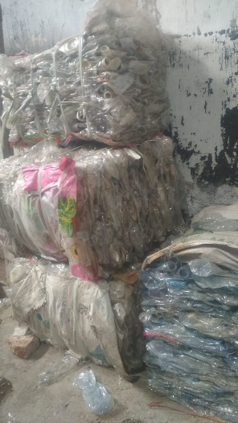
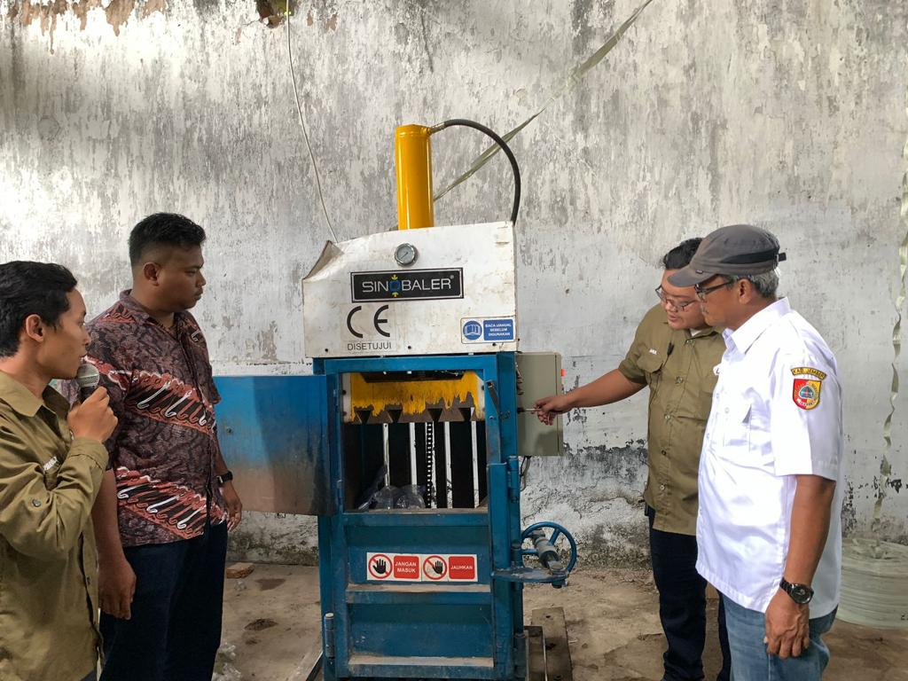
This process is carried out for PET and soft plastics and includes baling tools and components, Personal Protective Equipment (PPE), and a detailed operational manual. Follow the procedure in the manual to make a 40kg baled press. After the baling process is completed, move, and stack the baling results in the storage area adjacent to the door for easy transportation access.

Figure 9. Baled Press Process

- Shredding Process
This process is carried out for HDPE, LDPE, PP materials, and includes shredding equipment and components, Personal Protective Equipment (PPE), and detailed operational manual. The shredding process will reduce the volume of HDPE, LDPE, or PP up to 20-30% from the volume of raw materials. The shredding process can be undertaken with the minimum volume of 500kg for every 6 working hours and maximum of 800kg every 6 working hours. After the shredding process is completed, put the shredded materials into sacks and move it to the storage area and stack it based on each type of material.

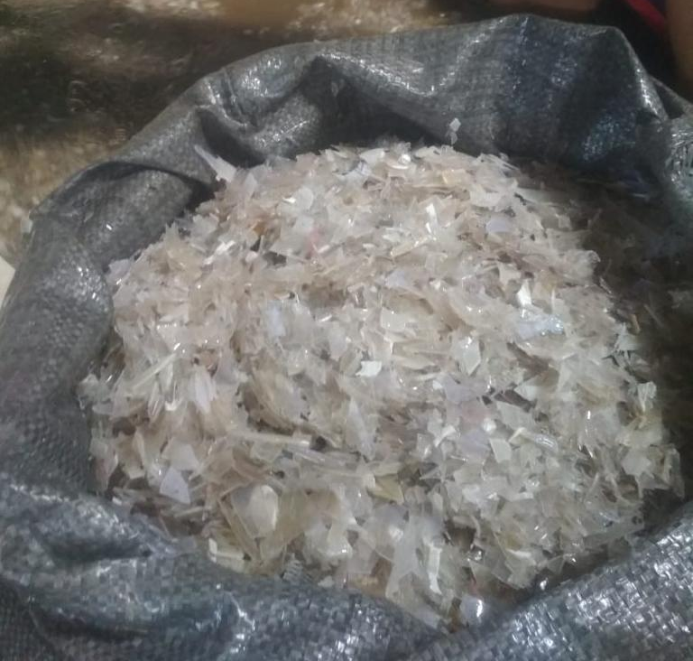
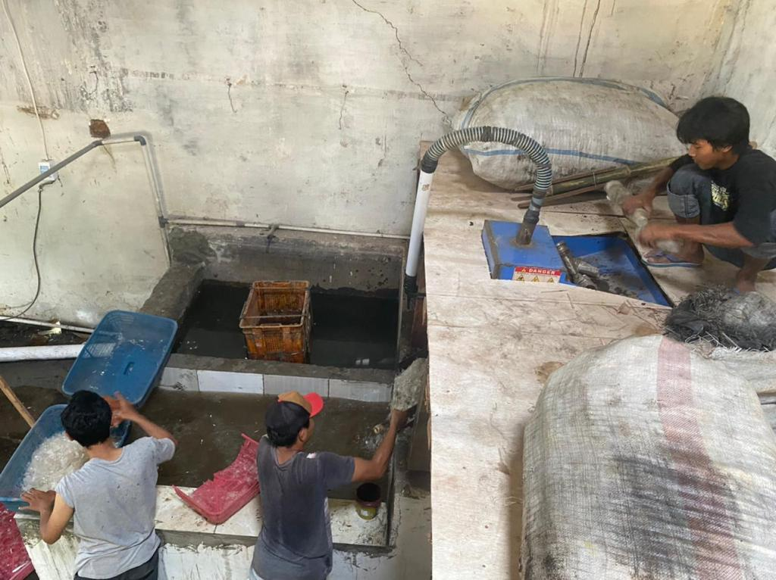

Figure 10. Shredding Process

- Check the results of recycling process
The recycling results shall be weighed and labeled with relevant information, which are batch number, type of material, color, quality (A1, A 2, B, C1 or C2), weight, processing date, operator name and location.

- Sales & Issuance of Receipt
Submit the sales data into Imaji Lingkungan’s local website (http://recycle-hub.imajisociopreneur.id ) by filling in the required data, then issue the receipt.
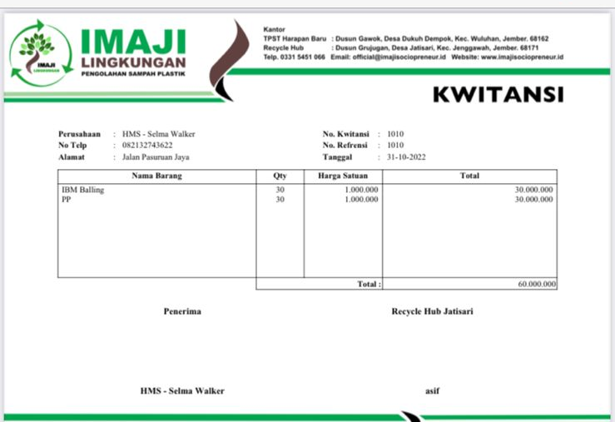
Figure 11. Sample of Receipt

- Deliver the products to the customers
After the materials are ready to be delivered, prepare a Delivery Order consists of the following information: number, type, destination, vehicle number and the driver’s name.
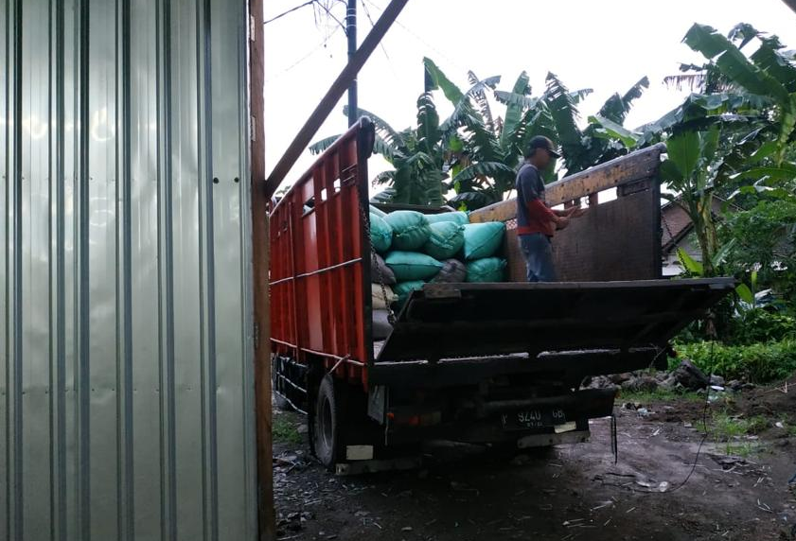
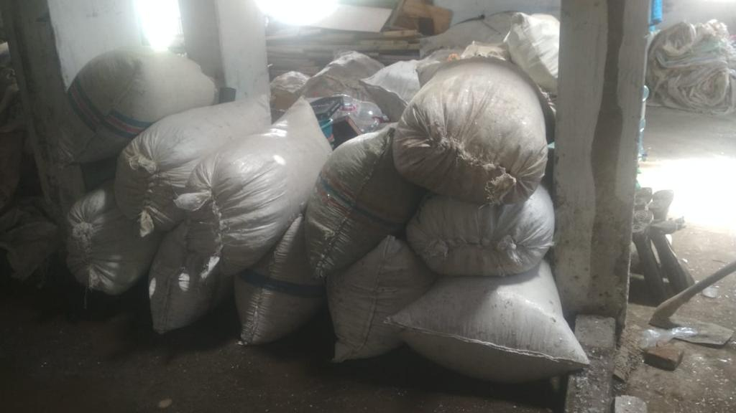

Figure 12. Recycled materials that have been packed and ready for delivery
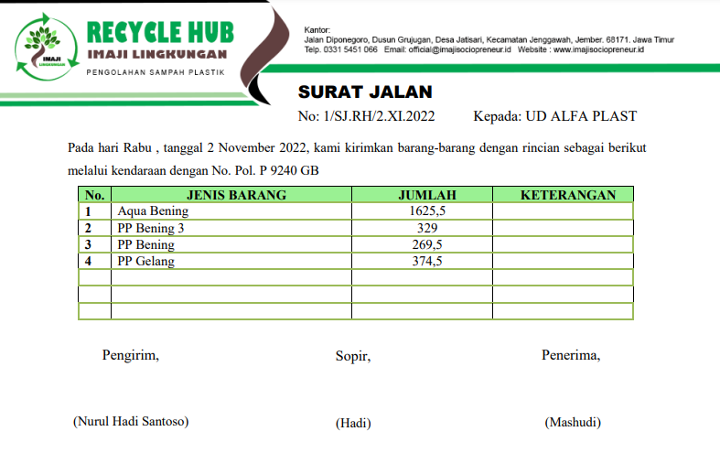
Figure 13. Sample of Delivery Order

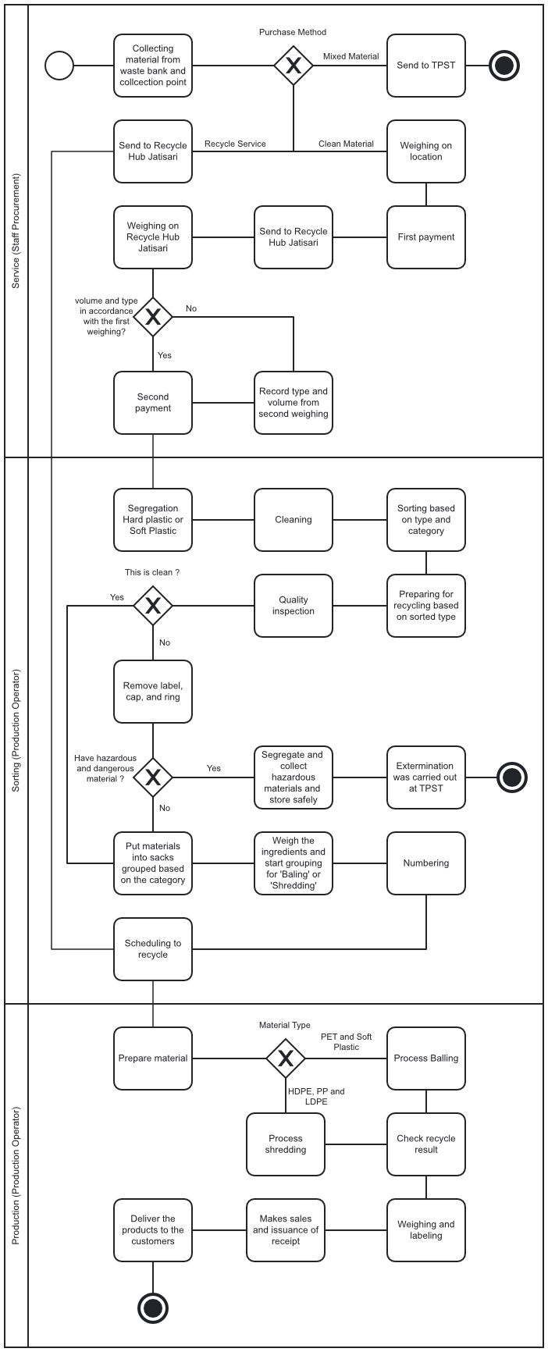
Flow Chart Standard Operating Procedure Recycle Hub

Contact Persons
No. | Person in Charge | Unit | Phone Number
1. | Rohman Abadi | Director Imaji Lingkungan | 0857-3081-9120
2. | Nurul Adi Fatah | Production Operator | 0896-5460-8420
3. | Ms. Adinda | Purchasing and Procurement Operator | 0857-8427-4829
4. | Mr Dwi Widianto | Chairman of the New Hope TPST | 0823-3534-6176
5. | Mr. Mashudi Susanto | Alpha Plastic | 0813-5826-7120
6. | Mr. Yasin | Barokah Jaya | 0852-3622-8094
7. | Sri Wigati | Mawar Putih Waste Bank | 0838-3455-8101
8. | Risa | Saesa Waste Bank | 0822-1324-5980
9. | Mr. Fatchur | Mulia Jaya Waste | 0823-3533-5562
10. | Imaji Sociopreneur Office | Imaji Sociopreneur | 03315-451-066
11. | Police station | Police Jember | 0331-487-012
12. | extinguisher Fire | BPBD Jember | 0331-321-213
13. | Hospital | Jember Hospital | 0331-487-441

PPE is personal protective equipment consisting of boots, gloves and masks.

